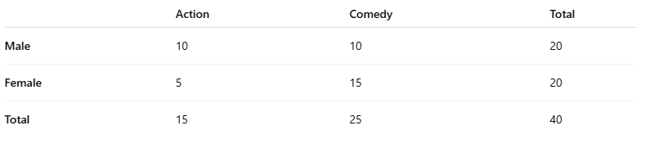

1

2

3

4

A

Grand Total

Col totals

Row totals

Chi-square test

• Null **Hypothesis (H₀):** Gender and movie preference are **independent** (no relationship).

• Alternative **Hypothesis (H₁):** Gender and movie preference are **dependent** (related).

Expected values

Expected = (Row Total * Column Total) / Grand Total

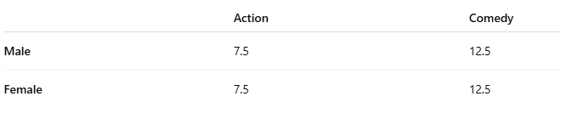

6

7

Chi-Square Function

=CHISQ.TEST(actual_range, expected_range)

=CHISQ.TEST(B2:C3, B6:C7)

Conclution

**p-value = 0.1026 > 0.05** → Fail to reject H₀.